

GRADE 11
JULY EXAMINATION 2013
HISTORY
PAPER 2 (SOURCE PAPER)
3 hours 200 marks

INSTRUCTIONS:
- This paper consists of 6 pages plus a Source Booklet of 3 pages
- There are THREE sections in this exam
- SECTION A – Question 1-3-Individual Source Analysis (60)
- SECTION B – Question 4-Source Based Question (90)
- SECTION C – Question 5-Source Based Essay (50)
- You are to answer all the questions in the book provided.
- Make sure your answers are correctly numbered and clearly written. Write on both sides of the page.
- Accurate and adequate factual knowledge is essential; equally important in answering the questions is the ability to use relevant information critically.
- Time yourself and do not spend too much time on one question and too little on another.
- When you have finished your exam put your question paper at the back of the answer book.

EXAMINER: MRS J-A MOGG MODERATOR: MRS A LOURENCO

SECTION A INDIVIDUAL SOURCE ANALYSIS QUESTIONS

QUESTION 1

This question will focus on your ability to read, comprehend, analyse and evaluate a written source.

Record of understanding between ANC and NP
Mr. State President, FW de Klerk, and members of your delegation;
Members of the delegation of the African National Congress;
Ladies and gentlemen.
Allow me to express my appreciation that we have finally been able to meet. At the very least, the simple act of our coming together at this level is bound to send a signal of hope among all South Africans. We are duty-bound not to disappoint them.
I would like to congratulate Secretary-General Cyril Ramaphosa, Minister Roelf Meyer and their assistants for their outstanding work in preparation for the Summit. The ultimate accolade, however, goes to the people of South Africa who, in their various ways, have ensured that the issues of peace and democracy remain high on the political agenda.
There were moments when the temptation to despair seemed most attractive. Indeed, the issues would not have been critical, and the urgency to address them not acute, if difficulties did not arise on the way.
Now we have assembled - representatives of the ANC and the government - to seek practical solutions to the most urgent questions facing our country. I take this opportunity to welcome back to our midst the political prisoners who have just been released, and hope that the others will join us soon. This important step, and practical measures to address violence, will help create the climate so necessary for substantive negotiations to resume.
We have come here in the hope that by the time this Summit ends, a firm basis will have been laid for the resumption of negotiations.
This is what all our people want. This is what our economy needs. This is what our country yearns for.

Statement by Nelson Mandela, President of the ANC, at the opening of the ANC/NP government summit 26 September 1992.
http://www.sahistory.org.za/archive/record-understanding-between-anc-and-np-statement-nelson-mandela-president-anc-opening-ancnp
PLEASE TURN THE PAGE
  - What was the Record of Understanding and why was it signed? (4)

  - Using background information indicate how the IFP reacted to the Record of Understanding? (4)

  - What political position did the following three people occupy?

    - Cyril Ramaphosa (2)
    - Roelf Meyer (2)
    - Nelson Mandela (2)

  - Write down THREE facts from the source that would have encouraged Mandela to see the Record of Understanding as a solid platform for negotiation. (6)

[20]

PLEASE TURN THE PAGE

QUESTION 2

This question will focus on your ability to understand and analyse a visual source.

The Elusive Creature
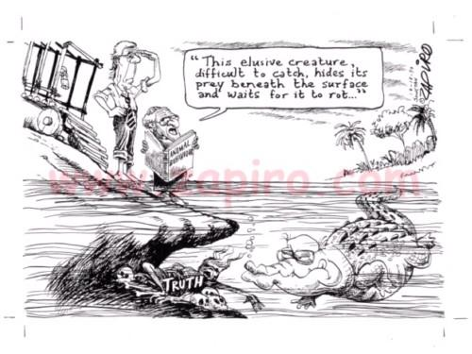

A cartoon by Jonathan Zapiro, published in The Sowetan on 17 Dec 1997.
  - Identify the THREE characters represented in the cartoon. (3)

  - Why has the one character been drawn as a crocodile? Explain your answer. (4)

  - What was Zapiro’s intention in drawing this cartoon? Give 4 good reasons. (8)

  - What are the limitations of this cartoon for an historian studying the TRC? Give 5 limitations. (5)

[20]

PLEASE TURN THE PAGE
QUESTION 3

This question will focus on your ability to understand and analyse a photograph.

Lindsaye Tshabalala’s Fiery Death

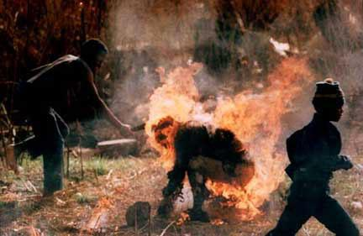

Photograph by Greg Marinovich, 1990

For the above photo of a man hacking at a burning man with a machete, Marinovich would later win a Pulitzer Prize. A Zulu named Lindsaye Tshabalala was suspected of spying for Inkatha, and was executed by African National Congress supporters.

  - Place the photo above in historical context. (5)

  - Using background information explain why there was hostility between Inkhatha and the ANC. (4)

  - What was your immediate reaction to the photograph? Explain your response. (3)

  - Do you think Marinovich deserved to win the Pulitzer Prize for this photo? Explain your answer. (4)

  - What kind of problems would a photo like this have for historians studying this time period? Give four valid reasons. (4)

[20]

PLEASE TURN THE PAGE
SECTION B SOURCE BASED QUESTIONS

THE COLD WAR

QUESTION 4

Study the sources in the Source Booklet and answer the following questions:

Refer to Sources A and C

Both of these sources are public speeches about the Marshall Plan.

4.1 How does the American view in Source A differ from the Soviet view expressed in Source C? Give three differences. (6)

4.2 Why do these two sources differ? Give three differences. (6)

4.3 Why do you think the Soviets were suspicious of the Marshall Plan? Refer to Source C. (4)

Refer to Sources B, E and F

4.4 What can you learn about the Marshall Plan from these three sources? Write down five things you can learn. (10)

4.5 All of these sources are photographs. What problems (limitations) do historians have with photos as historical evidence? Write down four problems. (8)

Refer to Source D

4.6 Who was the driver of the ‘Liberty Hotel’ bus on the left? (2)

4.7 Which two countries has he already helped onto the bus? (4)

4.8 Why do you think Stalin is seen pushing Hungary onto the other bus? (2)

4.9 Which ‘bus’ did Bulgaria eventually join? (2)

4.10 Which bus driver was the cartoonist more likely to have supported? Explain your answer. (4)

PLEASE TURN THE PAGE

Refer to Sources G and H

4.11 use your own knowledge to explain why there was a refugee problem after WW2. Give 3 reasons. (6)

4.12 Explain why refugees would cause problems for the economy in Europe. Give 3 causes. (6)

Refer to Sources I and J

4.13 Evaluate the purpose (2), value (4) and limitations (4) of both cartoons. Deal with each cartoon separately and make sure you label them correctly. (20)

Refer to all the Sources

4.14 Write down whether the following statements are TRUE or FALSE

4.14.1 The economies of Europe were in ruins (2)

4.14.2 The USA feared communist take-overs in Europe (2)

4.14.3 The USSR was prepared to take responsibility for the economic recovery of Europe (2)

4.14.4 The USA wanted European markets for is goods (2)

4.14.5 The Soviet Union had emerged from the war as the world’s greatest power (2)

[90]

PLEASE TURN THE PAGE
SECTION C SOURCED BASED ESSAY

In this section of the paper, you will use all the sources to extract relevant information to answer a question.

You will be expected to:

- Identify the relevant information from each source and reference the sources.
- Group the sources and use them to back up what you are saying.
- Do not use the ‘shopping list method’.
- Take a definite stand on the question.
- Build a logical argument or discussion.
- Acknowledge a counter argument, if there is one.
- Communicate your answer clearly.

QUESTION 5

Using all the sources determine whether the political causes of the Marshall Plan were more important than the economic causes.

[50]

200 marks

